**Creation of tables**

|  |  |
| --- | --- |
| Team Id | LTVIP2025TMID29041 |
| Project Name | Calculating family expenses |
| college | Kandula Lakshumma Memorial College of Engineering for Women |
| course | Computer Science  Engineering |

**4.Configure The Form:**

Customize the user interface to display only the relevant fields in a clear, organized, and user-friendly layout-making it easier to enter, view and manage expense records efficiently

* Go to All >> In the filter search for Family Expenses >> Open Family Expenses
* Click on New
* Go to the Header and right click there>> click on Configure >> Select Form Design

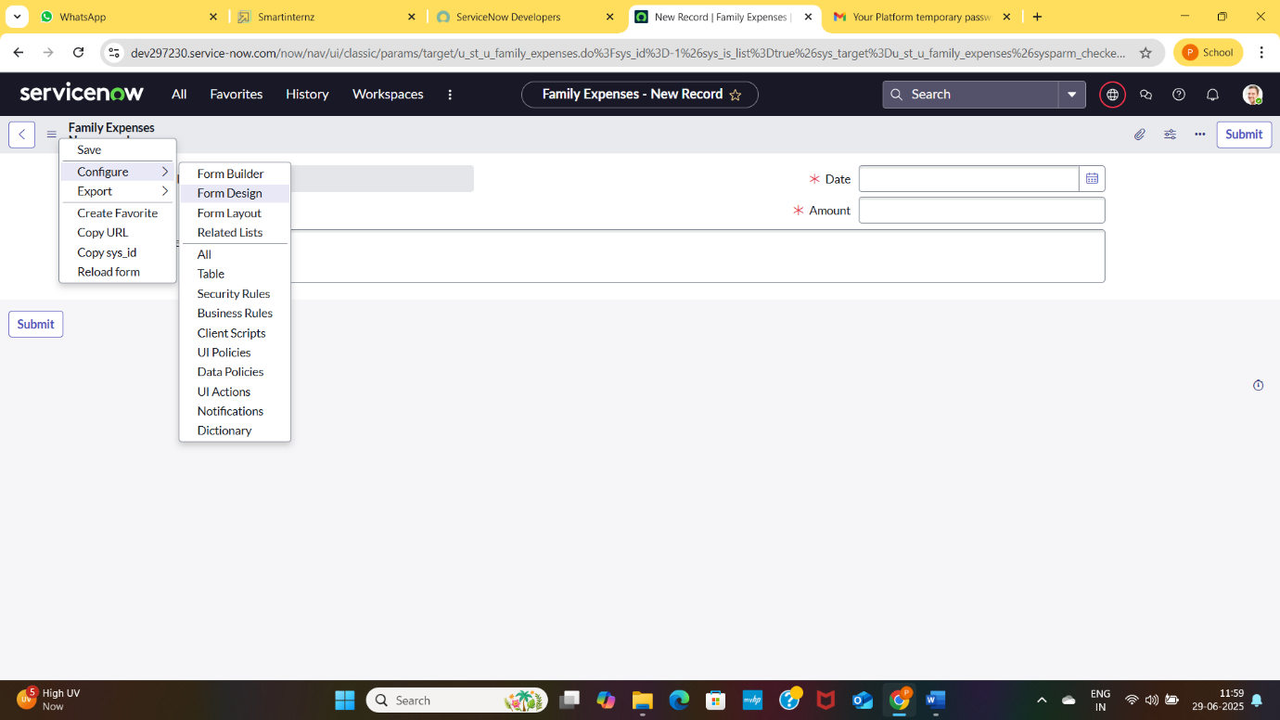

* Customize or Drag Drop the form as per your requirement.

* Make Number Read-Only Field by clicking on the gear icon and checking Read-Only
* Make Date, Amount Mandatory Field by clicking on the gear icon and checking Mandatory
* Click on Save.